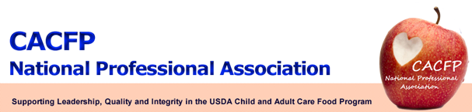
February Message of the Month
CACFP NPA Membership
If you or your agency has not yet renewed your membership for 2011-2013, it’s not too late. Remember, when you pay your fees this year, you will have a 2-year membership. The membership form can be easily found at: http://www.cacfpnpa.org/2011-2013%20Membership%20Form%20State%20Agency.doc. If you have any questions or need clarification about membership payment; please contact Connie Bell at 505-827-9964 or via email at connie.bell@state.nm.us. Being a member gives you access to all areas of the updated website, keeps you on our email list and entitles you to the member discount for conference registration.
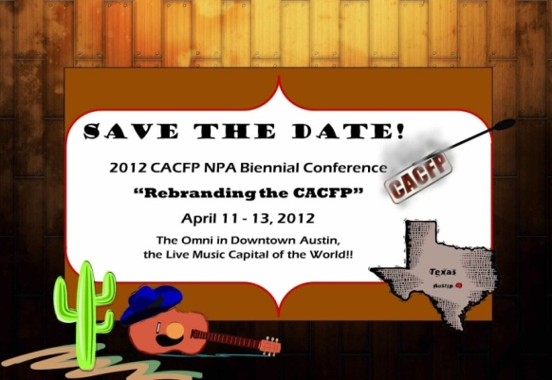
2012 CACFP NPA Conference – April 11-13, 2012
The Board is putting the finishing touches on the 2012 conference. The conference agenda is filled with 2½ days of great speakers. Sessions on the appeal process, budgeting and risk analysis, obesity prevention, the At-Risk Supper program and a presentation by two members of the IOM Obesity Prevention in Young Children committee are planned. We also have Jim Bearden, a nationally-recognized motivational speaker, on the agenda for Friday. So plan to stay all three days. Registration and hotel information is available on our website – http://www.cacfpnpa.org. New for this year - attendees can pay the registration fee with PayPal!
- Exhibitors: If your state is interested in exhibiting, there is still time to secure a table. For more information, contact Benedict Onye at benedict.onye@ct.gov.

USDA Updates

- The newly updated Family Day Care Homes Monitor Handbook is available on PartnerWeb.
- A new memo, Guidance on Income Eligibility and Determination Duration, is also available now on PartnerWeb.
- Be on the lookout for a new memo on At-Risk Suppers and Snacks Q & A.
- A memo on additional State requirements for CACFP is also in the works and should be released soon.
- The memo on the new process for using Census data to determine eligibility in CACFP and SFSP was placed on PartnerWeb on February 13, 2012. Instructions on using the new system were also posted. USDA is offering a webinar for State agencies on how to use the Census data on February 22nd.
- Finally, the proposed changes to the CACFP meal pattern should be available for public comment by June of this year.

Speaking of PartnerWeb, USDA is planning to reorganize the site to make it more user-friendly. If you have suggestions, let your NPA Regional Representative know. They will forward it on to HQ.

